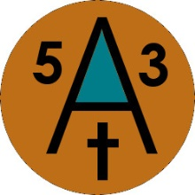
Biography
What elements need to come together to form a kick ass blues band? Could it be two guys on a church praise team, a retired Navy man and pure luck?
Garrett Hobson and Eduardo Barraza were on a praise team in Alamogordo, New Mexico. During team practice, they had discussed starting a recording studio. After years of planning, buying studio equipment and obtaining property their dream came true. They opened Studio Productions of Tularosa (SPOT).
​Garrett had been in bands in his younger days playing anything with strings. Eduardo had taken up percussion instruments and they were now the studio musicians.
​One of their first customers was Darrell Hall a retired Navy man, who was working at Holloman Air Force Base in Alamogordo. Darrell would record his original music with Garrett and Eduardo as backup musicians. Soon they were collaborating, writing new material under the in-house band name '53 Across', since they were all born in 1953.
​A very talented young guitarist, Michael Gutierrez, came to the studio and was also helping as a studio musician. Soon He was playing with '53 Across'.
​Darrell, who had a blues band called 'Blue Belly', started playing ‘53 Across’ songs with his band. It was soon decided that the two bands would join together under the name '53 Across'. This merger brought new band members Greg Bouten and Marc Bartholomew. This was the final step in forming this dynamic blues band call '53 Across'.
​
​
​

